How do I use nc to scan Linux, UNIX and Windows server port scanning?

If nmap is not installed try nc / netcat command as follow. The -z flag can be used to tell nc to report open ports, rather than initiate a connection. Run nc command with -z flag. You need to specify host name / ip along with the port range to limit and speedup operation:

|  |
| --- |
| *## syntax ##*  nc -z -v **{**host-name-here**}** **{**port-range-here**}**  nc -z -v host-name-here **ssh**  nc -z -v host-name-here 22  nc -w 1 -z -v server-name-here port-Number-her    *## scan 1 to 1023 ports ##*  nc -zv vip-1.vsnl.nixcraft.in 1-1023 |

Sample outputs:

Connection to localhost 25 port [tcp/smtp] succeeded!

Connection to vip-1.vsnl.nixcraft.in 25 port [tcp/smtp] succeeded!

Connection to vip-1.vsnl.nixcraft.in 80 port [tcp/http] succeeded!

Connection to vip-1.vsnl.nixcraft.in 143 port [tcp/imap] succeeded!

Connection to vip-1.vsnl.nixcraft.in 199 port [tcp/smux] succeeded!

Connection to vip-1.vsnl.nixcraft.in 783 port [tcp/*] succeeded!

Connection to vip-1.vsnl.nixcraft.in 904 port [tcp/vmware-authd] succeeded!

Connection to vip-1.vsnl.nixcraft.in 993 port [tcp/imaps] succeeded!

You can scan individual port too:

|  |
| --- |
| nc -zv v.txvip1 443  nc -zv v.txvip1 80  nc -zv v.txvip1 22  nc -zv v.txvip1 21  nc -zv v.txvip1 smtp  nc -zvn v.txvip1 **ftp**    *## really fast scanner with 1 timeout value ##*  netcat -v -z -n -w 1 v.txvip1 1-1023 |

Sample outputs:

[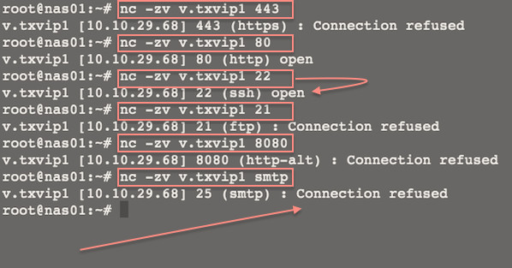](https://www.cyberciti.biz/faq/linux-port-scanning/scan-with-nc/)

Fig.01: Linux/Unix: Use Netcat to Establish and Test TCP and UDP Connections on a Server

Where,

1. **-z** : Port scanning mode i.e. zero I/O mode.
2. **-v** : Be verbose [use twice -vv to be more verbose].
3. **-n** : Use numeric-only IP addresses i.e. do not use DNS to resolve ip addresses.
4. **-w 1** : Set time out value to 1.

More examples:

$ **netcat -z -vv www.cyberciti.biz http**

www.cyberciti.biz [75.126.153.206] 80 (http) open

sent 0, rcvd 0

$ **netcat -z -vv google.com https**

DNS fwd/rev mismatch: google.com != maa03s16-in-f2.1e100.net

DNS fwd/rev mismatch: google.com != maa03s16-in-f6.1e100.net

DNS fwd/rev mismatch: google.com != maa03s16-in-f5.1e100.net

DNS fwd/rev mismatch: google.com != maa03s16-in-f3.1e100.net

DNS fwd/rev mismatch: google.com != maa03s16-in-f8.1e100.net

DNS fwd/rev mismatch: google.com != maa03s16-in-f0.1e100.net

DNS fwd/rev mismatch: google.com != maa03s16-in-f7.1e100.net

DNS fwd/rev mismatch: google.com != maa03s16-in-f4.1e100.net

google.com [74.125.236.162] 443 (https) open

sent 0, rcvd 0

$ **netcat -v -z -n -w 1 192.168.1.254 1-1023**

(UNKNOWN) [192.168.1.254] 989 (ftps-data) open

(UNKNOWN) [192.168.1.254] 443 (https) open

(UNKNOWN) [192.168.1.254] 53 (domain) open